In loving memory

of

Ena Veronica Jackson

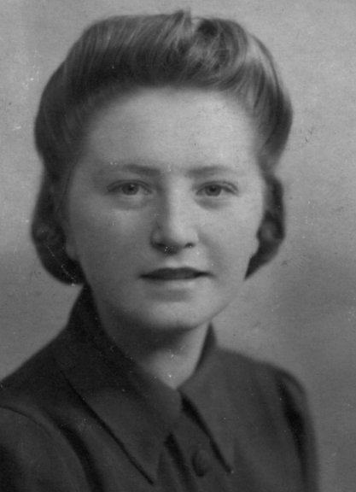

18th August 1925 – 3rd February 2007

St Andrew’s Church

Orford with Longford

Tuesday 13th February 2007

followed by interment at Fox Covert Cemetery

Order of Service

ALL STAND as the funeral procession enters the church. Once the family are seated, please SIT.

The Priest reads one or more scriptural sentences.

Introduction

Priest: We meet in the name of Jesus Christ, who died and was raised to the glory of God the Father. Grace and mercy be with you.
All: Amen.

The priest introduces the service

Priest: Let us pray: (please remain seated)

Almighty God, you judge us with infinite mercy and justice, and love everything you have made. In your mercy turn the darkness of death into the dawn of new life, and the sorrow of parting into the joy of heaven; through our Saviour, Jesus Christ. Amen

All: Merciful Father, hear our prayers and comfort us; renew our trust in your Son, whom you raised from the dead; strengthen our faith that all who have died in the love of Christ will share in his resurrection; who lives and reigns with you, in the unity of the Holy Spirit, one God, now and for ever. Amen

The Ministry of the Word

Hymn: “Make me a channel of your peace” (please stand)

Make me a channel of your peace.
Where there is hatred let me bring your love.
where there is injury, your pardon, Lord,
and where there's doubt, true faith in you.
Oh Master, grant that I may never seek
so much to be consoled as to console,
to be understood, as to understand,
to be loved, as to love with all my soul.

Make me a channel of your peace.
Where there's despair in life, let me bring hope.
Where there is darkness, only light,
and where there's sadness, ever joy.

Oh Master, grant that I may never seek
so much to be consoled as to console,
to be understood, as to understand,
to be loved, as to love with all my soul.

Make me a channel of your peace.
It is in pardoning that we are pardoned,
in giving of ourselves that we receive,
and in dying that we're born to eternal life.

The Scriptural Reading

Please sit for a reading from the gospel according to St John (Jn 14. 1-6)

"Do not let your hearts be troubled. Trust in God; trust also in me. In my Father's house are many rooms; if it were not so, I would have told you. I am going there to prepare a place for you. And if I go and prepare a place for you, I will come back and take you to be with me that you also may be where I am. You know the way to the place where I am going."

Thomas said to him, "Lord, we don't know where you are going, so how can we know the way?"

Jesus answered, "I am the way and the truth and the life. No one comes to the Father except through me.

This is the word of the Lord
All: Thanks be to God

The Address

We remain seated to listen to Schubert’s “Ave Maria”

The Prayers:

Priest: God of mercy, Lord of life, you have made us in your image to reflect your truth and light: we give you thanks for Ena, for the grace and mercy she received from you, for all that was good in her life, and especially for the memories we treasure today.

(after a short period of silence)

Lord, in your mercy
All: hear our prayer.

Priest: You promised eternal life to those who believe. Remember for good your daughter Ena as we also remember her. Hear our prayers for all who have died, including Jimmy, and any others who come to mind today. Bring all who rest in Christ into the fullness of your kingdom where sins have been forgiven and death is no more.

Lord, in your mercy
All: hear our prayer.

Priest: Your mighty power brings joy out of grief and life out of death. Look in mercy on Ena’s, her daughter Ena and son in law, Stephen, and granddaughter Laura, Ena’s sisters and their families including Sheila, and all who mourn at this time. Give them patient faith in times of darkness. Strengthen them with the knowledge of your love.

Lord, in your mercy
All: hear our prayer.

Priest: You are tender towards your children and your mercy is over all your works. Heal the memories of hurt and failure. Give us the wisdom and grace to use aright the time that is left to us here on earth, to turn to Christ and follow in his steps in the way that leads to everlasting life.

Lord, in your mercy
All: hear our prayer.

God of mercy, entrusting into your hands all that you have made and rejoicing in our communion with all your faithful people, we make our prayers through Jesus Christ our Saviour. Amen.

Priest: Let us pray with confidence as our Saviour has taught us

All: Our Father, who art in heaven, hallowed be thy name; thy kingdom come; thy will be done; on earth as it is in heaven. Give us this day our daily bread. And forgive us our trespasses, as we forgive those who trespass against us. And lead us not into temptation; but deliver us from evil. For thine is the kingdom, the power and the glory, for ever and ever. Amen.

Hymn: “How great thou art” (please stand)

O Lord my God! When I in awesome wonder
Consider all the works Thy hand hath made,
I see the stars, I hear the mighty thunder,
Thy power throughout the universe displayed:
Then sings my soul, my Saviour God to Thee,
How great Thou art! How great Thou art!
Then sings my soul, my Saviour God to Thee,
How great Thou art! How great Thou art!

When through the woods and forest glades I wander
And hear the birds sing sweetly in the trees;
When I look down from lofty mountain grandeur,
And hear the brook, and feel the gentle breeze;
Then sings my soul ...

And when I think that God his Son not sparing,
Sent Him to die - I scarce can take it in;
That on the cross my burden gladly bearing,
He bled and died to take away my sin:
Then sings my soul ...

When Christ shall come with shout of acclamation
And take me home - what joy shall fill my heart!
Then shall I bow in humble adoration
And there proclaim my God, how great Thou art!
Then sings my soul ...

Commendation and Farewell [please remain standing]

Priest: Let us commend our sister Ena to the mercy of God our Maker and Redeemer.

The coffin is sprinkled with holy water taken from the font

Priest: With this water we call to mind Ena’s baptism. As Christ went through the deep waters of death for us, so may he bring us to the fullness of resurrection life with Ena and all the redeemed.

God our creator and redeemer, by your power Christ conquered death and entered into glory. Confident of his victory and claiming his promises, we entrust Ena to your mercy in the name of Jesus our Lord, who died and is alive and reigns with you, now and for ever. Amen

All: Heavenly Father, in your Son Jesus Christ you have given us a true faith and a sure hope. Strengthen this faith and hope in us all our days, that we may live as those who believe in the communion of saints, the forgiveness of sins and the resurrection to eternal life; through Jesus Christ our Lord. Amen.

Priest: May God, in his infinite love and mercy, bring the whole Church, living and departed in the Lord Jesus, to a joyful resurrection, and the fulfilment of his eternal kingdom. Amen.

As the procession leaves church, ‘One fine day’ will be played. Please remain seated for the start of the piece, then follow the family.

Acknowledgement: Common Worship: Pastoral Services, material from which is included in this service, is copyright © The Archbishops’ Council (2000)

Ena and her family would like to thank:

Auntie Sheila for her support
while Ena has been in Apple Court
and especially during the last few weeks

Tracey and John,
Ena’s neighbours in Patterdale Avenue,
who were always there for Mum and Dad.

Donations to
The Alzheimer’s Society and Apple Court
may be sent to
21 Beck Yeat,
Coniston
LA21 8HT

Please feel free to take this Order of Service with you.

